Storm Drain Art Contest Guidelines

The City of Carrollton is seeking local artists to paint inlets in Downtown! This contest is being held to promote awareness of stormwater pollution prevention and the role is plays in keeping our waters clean and safe.

# Eligibility:

Art submission is open to all Carrollton residents, organizations, and the immediate DFW area. Applicants must be at least 12 years of age. Minor entrants must have parental permission waiver. Organizations must have a single point of contact.

# Application Process:

Applications can be submitted by email to [andrea.mcclure@cityofcarrollton.com](mailto:andrea.mcclure@cityofcarrollton.com), through the contest website, or mailed/in person at:

City of Carrollton City Hall

Environmental Services Department

1945 E. Jackson Rd.

Carrollton, TX 75006

Applications must be received by **January 15, 2024.**

Artists must submit the design as it would be painted.

# Design Criteria:

The design must reflect at least one of the following art themes or similar:

* Why only rain should enter the storm drain;
* Relationship between stormwater runoff and local water sources; or
* The connections between people, wildlife habitat, and our drinking water.

No spray paint or airbrushing is permitted due to proximity to a storm drain. Artists must prevent paint or brush rinse water from entering the storm drain.

Artwork must be original. Designs may not include the use of intellectual property, trademarks, brands, images of illegal activity, or involve the attachment of any object to the storm drain.

The work must be appropriate to be viewed by all ages.

To deter graffiti vandalism, designs may not mimic or emulate the style of tags or graffiti.

The storm drain may not be used for advertisement or to promote a business, non-profit, political organization, product, or viewpoint.

# Winner criteria:

Winning designs will be selected by a committee. Committee decisions are final and are not subject to challenge. The City reserves the right, in its sole discretion, to reject all submissions. Up to 7 entries will be selected based on the design criteria. Submissions that are not chosen for this contest will be kept on file for future consideration. Artists will be notified if and when their design is selected.

# Timeline:

Submission deadline: January 15, 2024

Installation: March 2024

# Installation:

Artists will paint the submitted design onto a storm drain assigned by the city. Environmentally safe paint will be provided in addition to basic supplies including brushes and mixing containers. Safety cones, vests, knee pads and shade cover will be provided for installation of the art.

The artist may bring someone to help with the painting. Installation will take place on a weekend and should be completed the same day to prevent any issues from arising before sealant can be applied.

## Artist Responsibilities

* The selected artist shall be responsible for painting their design.
* The selected artist shall wear a safety vest during all painting.
* The selected artist shall be responsible for making sure no paint enters the storm drain during installation.
* The selected artist shall indemnify the City, and hold the City harmless, from any claims arising out of the artwork.

## City Responsibilities

* The city will power wash each storm drain prior to painting.
* The city will use primer to prep each inlet prior to painting.
* The city will provide paints, brushes, knee pads, containers for paint mixing, and shade cover.
* A City representative will meet with each artist at their assigned storm drain on the day of painting to review safety procedures and provide support, as requested; however, City staff will not help with painting.
* The City will handle all marketing and PR for this project including posting pictures of the storm drains online, and include a bio of the artist.

## Artist information/liability waiver:

Due to the public nature of this artwork and the possibility that the artwork may be vandalized, artists applying for this project must accept the risk that their artwork may be damaged, altered, or removed without notification and that the City of Carrollton is not responsible for maintaining the artwork once it is completed.

The artist further grants the City of Carrollton the exclusive right to reproduce, distribute, use, and display, in any medium, the selected artwork. City retains the sole right to remove all or a portion of the artwork at its discretion.

Artist’s Application

2023 Storm Drain Art Contest Application due: **January 15, 2024**

Name (artist or organization):

If organization, individual contact:

Address:

City:

State:

Zip:

Email:

Phone:

Title of work:

Briefly describe your interest in participating in this project:

Briefly describe the artwork in this proposal:

# Artist Certification Statement

I have read through the guidelines thoroughly, including information on eligibility, design criteria, selection, installation, copyright, and terms of agreement and agree to the guidelines.

* I certify that this artwork is my own and that reproduction will not violate the rights of any third party.
* I understand that this artwork will become the property of the City of Carrollton and may be displayed publicly.
* I understand that my name and artwork may appear in media releases and may be used in future promotions for water quality protection and education.
* I certify that all information provided on this application is true and complete.

Artist Signature: _______________________________________________________

Printed Name_________________________________________________________

Date: __________________________

I certify that I am the parent or legal guardian of the minor participant, and I give the minor consent to participate in the Storm Drain Art Contest upon reading through the guidelines thoroughly, including information on eligibility, design criteria, selection, installation, copyright, and terms of agreement and agree to the guidelines. I certify that all information provided on this application is true and complete.

Parent or Legal Guardian Signature: ____________________________________________

Printed Name______________________________________________________________

Date: __________________________

Submissions should be submitted through the website, emailed to [andrea.mcclure@cityofcarrollton.com](mailto:andrea.mcclure@cityofcarrollton.com), or delivered by mail or in person to:

City of Carrollton City Hall

Environmental Services Department

1945 E. Jackson Rd.

Carrollton, TX 75006

Hours (M-Th: 7:30 am - 5:30 pm / F: 7:30 am - 11:30 am)

# Frequently Asked Questions

1. Can I sign my artwork?

**Answer:** Yes, signatures are optional and may be included. There is a size limitation of 4” x 12”.

1. How long will my design be visible?

**Answer:** For as long as the paint lasts! We will be using a type of paint designed to achieve a long-lasting finish on exterior surfaces, concrete, and masonry. Your artwork will likely be on display for years!

1. Can I paint the surrounding sidewalk or into the road?

**Answer:** Yes, you do have the option to paint the surrounding area around the inlet.

1. What support will be given to the artist?

**Answer:** All materials for the project will be provided by the city, including paints, brushes, knee pads, containers for paint mixing, and shade cover. Artists will be provided with training before they begin painting regarding safety and pollution prevention. Traffic cones and safety vests will also be used. Information about the artist and their artwork will be shared through City social media.

1. Can I submit multiple designs?

**Answer:** Yes, entrants are allowed to submit as many designs as they would like for consideration.

1. Where are the inlets?

**Answer:** The inlets are in Downtown Carrollton; the inlet the artist will paint shall be assigned by the city.

# Inlet Examples

Example inlet photos. Inlets will be assigned to artists by the city. Storm drain markers will be removed prior to power washing but some glue residue may remain.

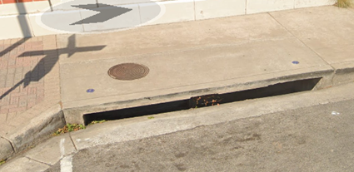

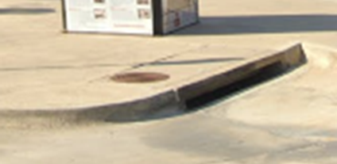

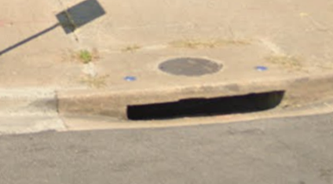

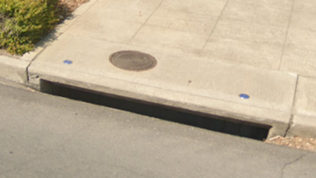

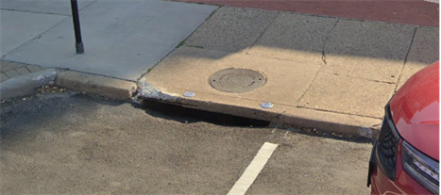

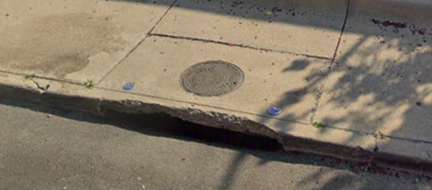

# Design Template

Below is a schematic of what the storm drain looks like installed. Please use the template provided on the next page to create your artwork. The “top” portion of the storm drain is required, the “bottom” portion is optional. If your design includes the area surrounding the inlet, please attach an example to the blank templates on the following pages.

9” 🡪

52” 🡪

134” 🡪

11” 🡪

42.5” 🡪

60.5” 🡪

6”

🡪

4.5”

🡪

4.5”

🡪

8.5”

🡪

Template 2

Template 1

TOP

required

TOP

required